Visiting Belize

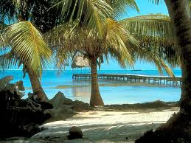

*Explore a Caribbean gateway where your senses come alive in one of the last unspoiled places on earth. With mystical Maya temples, pristine rainforests and a barrier reef, reward yourself with the soul-stirring charms of Belize.*

Planning Your Vacation

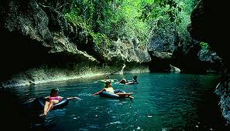

When In Belize

On the Insert tab, the galleries include items that are designed to coordinate with the overall look of your document. You can use these galleries to insert tables, headers, footers, lists, cover pages, and other document building blocks. When you create pictures, charts, or diagrams

Belize is a country located on the north eastern coast of Central America. It is the only country in the area where English is the official language

Sights To See

Some Great Tourist attractions are the Belize Barrier Reef, over 450 offshore Cayes (islands), excellent fishing, safe waters for boating, scuba diving, and snorkeling, numerous rivers for rafting, and kayaking, various jungle and wildlife reserves of fauna and flora, for hiking, bird watching, and helicopter touring, as well as many Maya ruins—support the thriving tourism and ecotourism industry. Of the hundreds of cave systems, it also has the largest cave system in Central America.

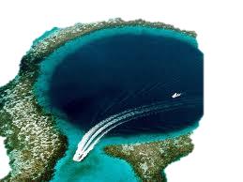

**Picking a Hotel**

Choosing the right hotel is always a trying task, and with the enormous number of promotions, deals and programs out there, it can be downright overwhelming. It doesn't help that these days most hotels have Web sites full of tantalizing photos and slick promotional copy that make you believe you'll be bathed in luxury as soon as you step foot into the lobby. Since every traveler has different needs when searching for a hotel, you'll need to ask yourself what's most important to you. Whether you're looking for a great deal, a great location or a great Bed and Breakfast

The air fare to Belize will depend on which part of the country you plan to visit, from where you are flying, and what class you plan to travel in. Air fare into the country usually ranges from $500 to $1000